**One To Many**

* One-to-Many relationship occurs when one record of one table corresponds to multiple records in another table.

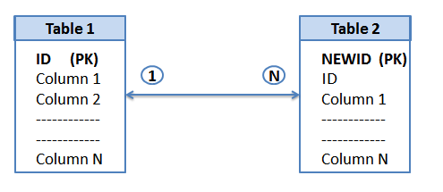

* One-to-Many relationship occurs when single record of one table corresponds to multiple records in another table
* **Using Hibernate Mapping File:**

<hibernate-mapping>

<classname=*"com.jspiders.hibernate.beans.PhoneNumber"*table=*"phone_numbers"*>

<composite-id>

<key-propertyname=*"*number*"*column=*"number"*/>

<key-propertyname=*"regno"*column=*"regno"*/>

</composite-id>

<propertyname=*"number_type"*column=*"number"*/>

</class>

</hibernate-mapping>

**Students Bean Changes**

**private** Set<PhoneNumber>phoneNumbers = **new** HashSet<PhoneNumber>();

//Generate Getters & Setters

**Students Mapping File Changes**

<setname=*"phoneNumbers"*table=*"phone_numbers"*cascade=*"all"***inverse=*"true"***>

<keycolumn=*"regno"*/>

<one-to-manyclass=*"com.jspiders.hibernate.beans.PhoneNumber"*/>

</set>

* **Using Annotations**

The @OneToMany annotation is used to create the one-to-many relationship between the Student and Phone entities.

@JoinColumn annotation is used to refer the linking columns in both the tables.

**About Inverse Keyword:**

* In Hibernate, only the “relationship owner” should maintain the relationship, and the “inverse” keyword tells which side is the owner to maintain the relationship.
* The “**inverse**” keyword is used with **one-to-many** and **many-to-many** relationships.

many-to-one & one-to-one doesn’t has inverse keyword

* In short, inverse=”true” means the current entity is the relationship owner, and inverse=”false” (default) means it’s not.